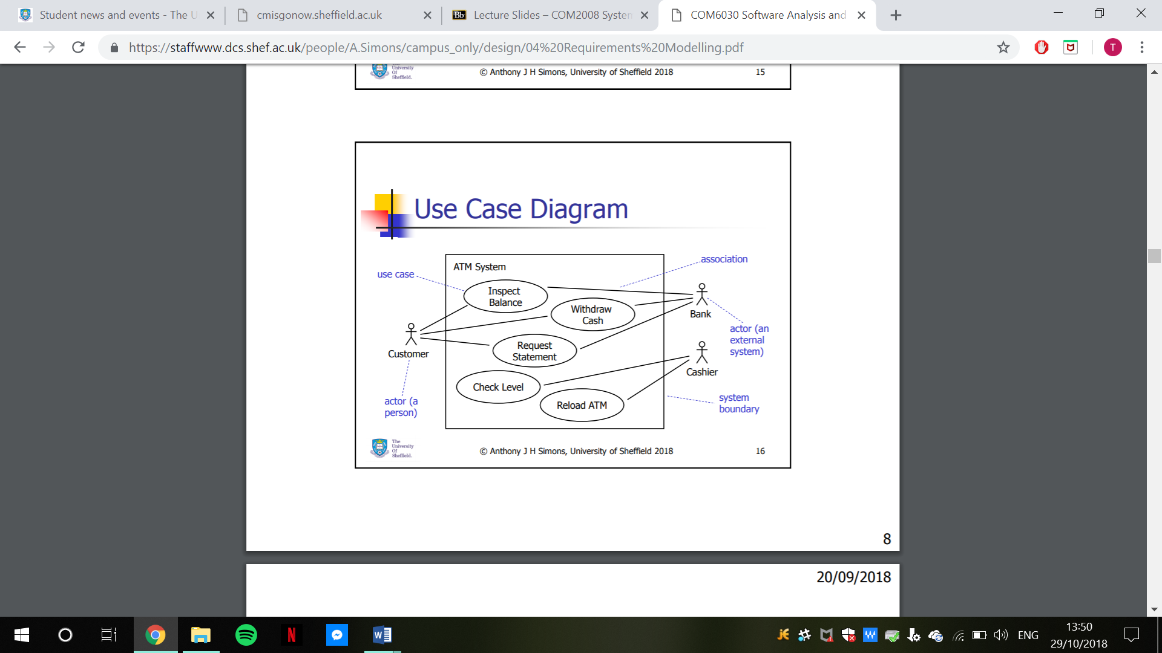UML Case Diagram:

Students

University System



Registrars

Teachers

Admin